This file contains the major additions to the project, it is essentially a minified version of the product backlog. Not all implementation timings are 100% correct, however they are accurate enough. There were many hours of research which weren’t documented. So if a sprint only totals 20 hours of work, then it was probably because there was lots of research going on.

Keep in mind I had no idea what I was doing – so everything had to be researched.

**Pre-starting SCRUM sprints**

The project was actually started around 1 month before it even got assigned. Hence there was a lot of background reading and quick spike solutions done before the start of the SCRUM sprints. I knew WebGL and GLSL would be very difficult to learn and realistically, only investing 400 hours (standard for 40 credit module) would have only yielded an average result. Hence the hours spent on the project are much higher.

Pre SCRUM sprints - Additions, overall time: 80h.

* Basic vertex and fragment shaders
* Index.html file
* Model view projection matrices
* Initial terrain, vertices connected with a triangle strip
* Caters added (removed later on)
* Broken user movement/terrain movement. When the user held down a key, all the vertices in the terrain would move. Rather than a camera.
* Terrain was rotating around its origin and later on around the user’s current position.
* Found new m4.js matrix library, rather than MDN library
* Started to use sphere geometries for rock generation

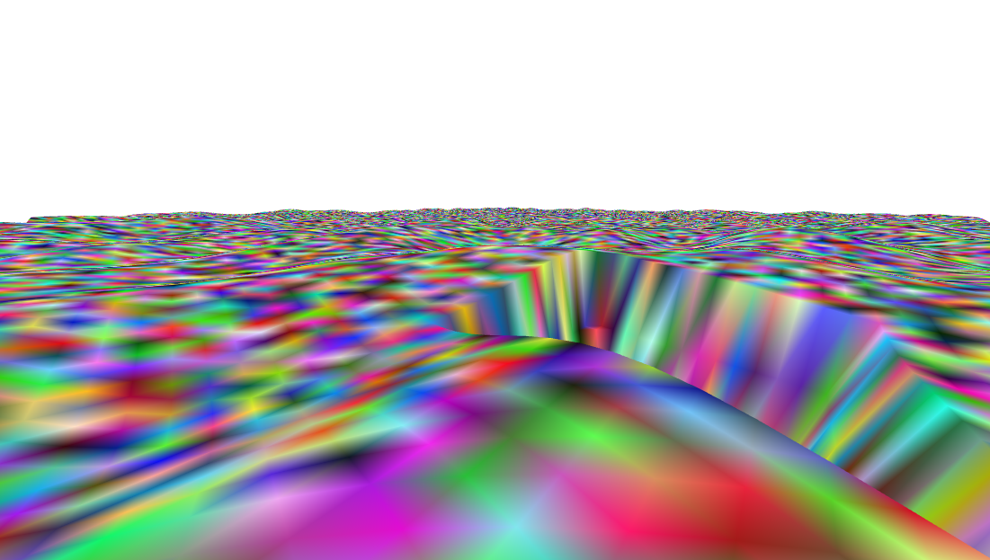

**Sprint 0**

Additions:

* Loading and saving functions (ongoing) (priority: 9) (time: 02h)
* Add in rocks (ongoing) (priority: 8) (time: 08h)
* Added prospecting rocks (priority: 8) (time: 0.5h)
* Build terrain (ongoing) (priority: 6) (time: 10h)
* Collision with terrain (ongoing) (priority: 6) (time: 05h)
* Redesign file structures (priority: 6) (time: 10h)

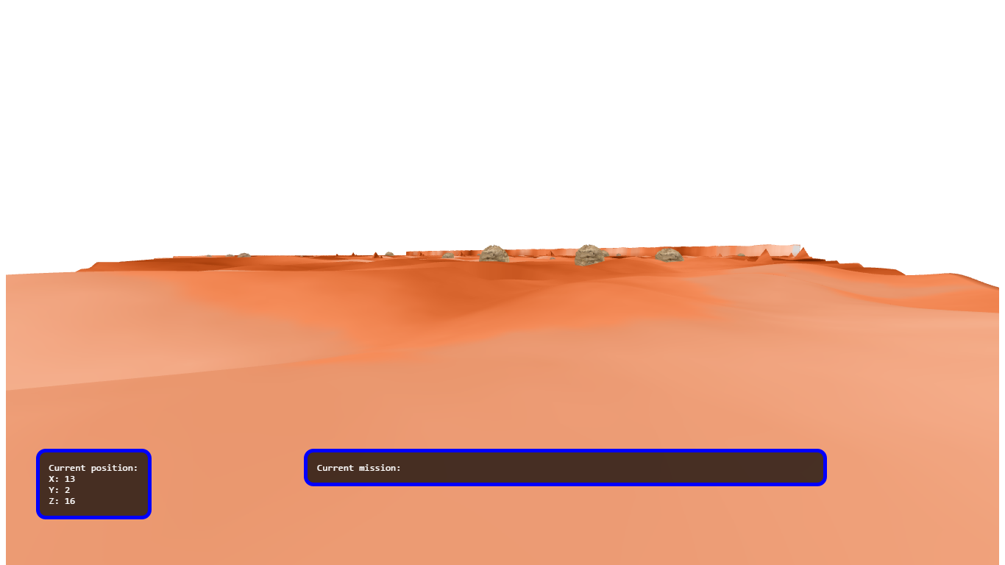

**Sprint 1**

Additions:

* Add in rocks (ongoing) (priority: 8) (time: 04h)
* Create missions for user (ongoing) (priority: 8) (time: 04h)
* Build terrain (ongoing) (priority: 6) (time: 05h)
* Build GUIs (priority: 6) (time: 05h)
* Texturing terrain (priority: 5) (time: 08h)
* Add audio (priority: 4) (time: 01h)
* Add in lighting (priority: 4) (time: 10h)

**Sprint 2**

Additions:

* Loading and saving functions (ongoing) (priority: 9) (time: 03h)
* FINISH building terrain (ongoing) (priority: 6) (time: 10h)
* Build GUIs (Minimap + nearest rock) (priority: 6) (time: 01h)
* Minimap (priority: 5) (time: 06h)
* Started test table (priority: 4) (time: 06h)



**Sprint 3**

VAOs were a nightmare to add and also to debug. The OBJ rocks also took ages because I tried to implement a WebGL OBJ loader myself. The actual program just scanned the text file, however something was wrong with the objects indices are so it eventually got removed. I replaced it with the webgl-obj-library as described in the appendices.

Additions:

* Added VAOs for terrain (priority: 4) (time: 20h)
* OBJ rock collision (priority: 4) (time: 15h)
* Removed horrible sphere rocks (priority: 4) (time: 04h)
* Created utility class (priority: 1) (time: 02h)
* Redesign and bug fixing
* Changed STATIC_DRAW renders to DYNAMIC_DRAW

**Sprint 4**

Adding the inventory took longer than it should. HTML tables where initially used to show the rock textures and where simply awful. The landers texture also had an annoying bug which meant it didn’t render, therefore it took longer to implement.

Additions:

* Added player inventory (priority: 6) (time: 15h)
* Remake GUIs (priority: 6) (time: 10h)
* Added HP (priority: 6) (time: 05h)
* Added rover lander (priority: 2) (time: 05h)

**Sprint 5**

Near the end of sprint 4 was when the mid project demonstrations took place. After this it became clear the game aspects where awful and I didn’t enjoy building them. I removed them and just focused on the WebGL graphics.

Removed: Player inventory, OBJ rocks, lander, XP, HP, game classes and more

Removing all of these game aspects, this set me back at least 60 hours.

There was really not much left after the removal of the game aspects. However, at least I had a solid engine to build on. I was also much more confident with WebGL so implementing features look less time.

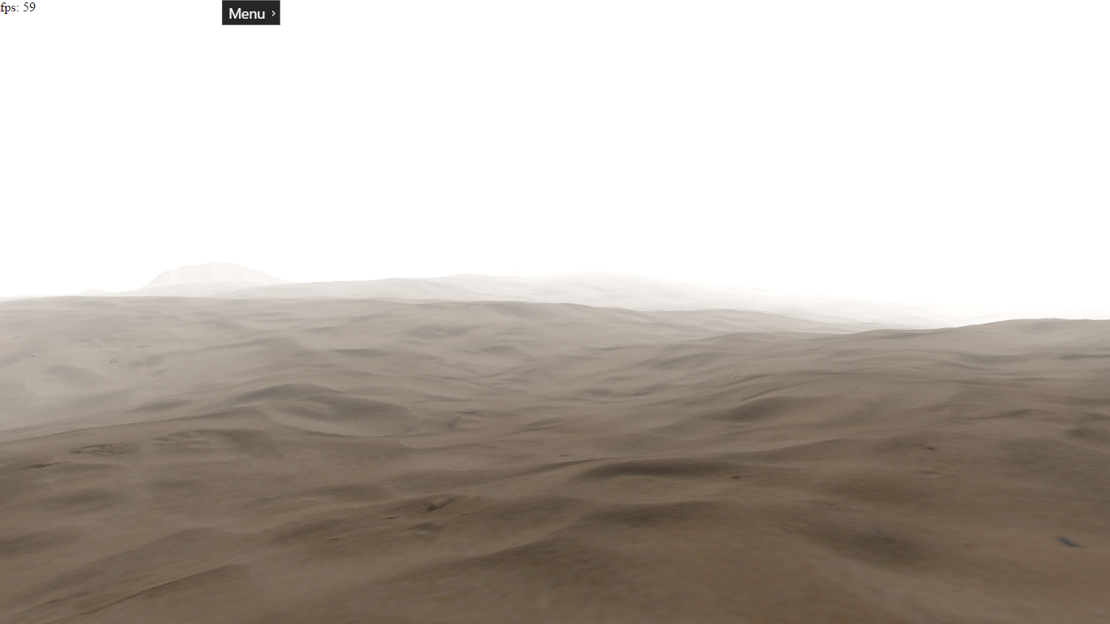

Additions:

* Started implementing instanced rendered rocks (priority: 7) (time: 35h)

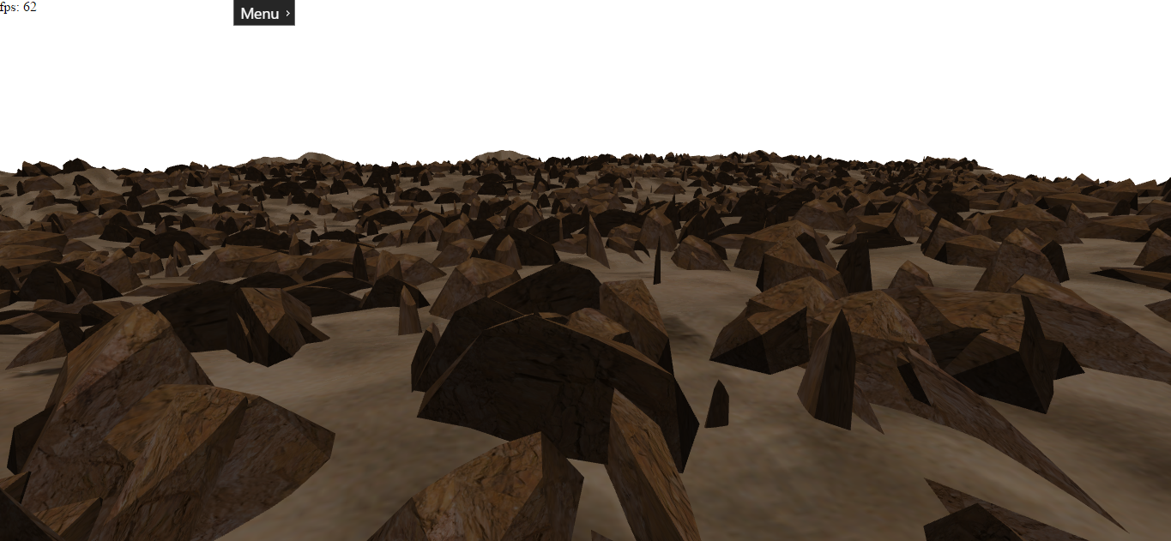

**Sprint 6**

Additions:

* Skybox (time: 10h) (priority: 7)
* Started implementing water (time: 45h) (priority: 7)
* Cool sand terrain texture. This, along with the stacked noise, adds even more detail to the terrain.

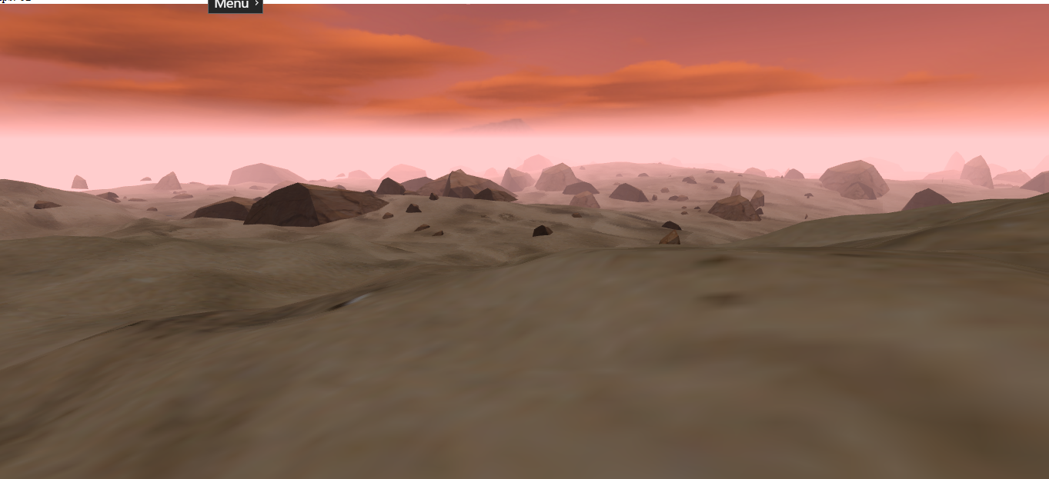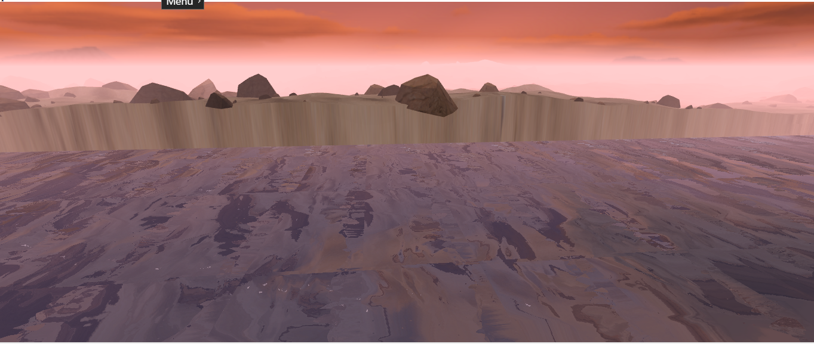

**Sprint 7**

Heavy hour week, fixing water bugs too ages.

Additions:

* Fixing horrible bugs with water (time: 60h) (priority: 7)
* Water specular highlights (time: 08h) (priority: 5)
* Added Fresnel effect on water (time: 05h) (priority: 3)

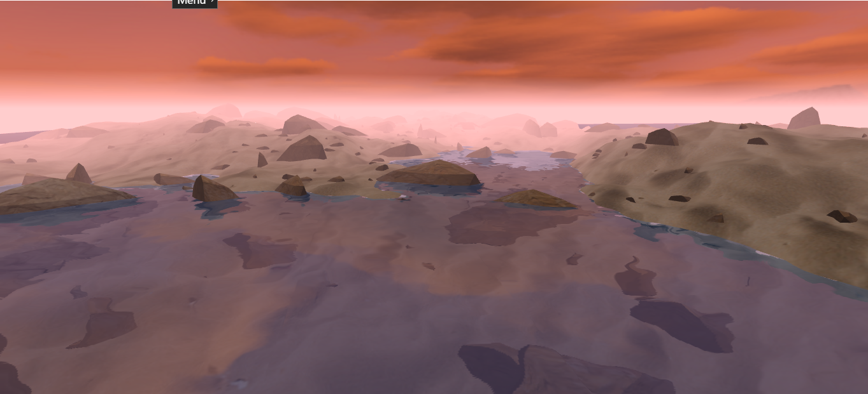

With specular highlights: (but made no sense as there was no sun in skybox)

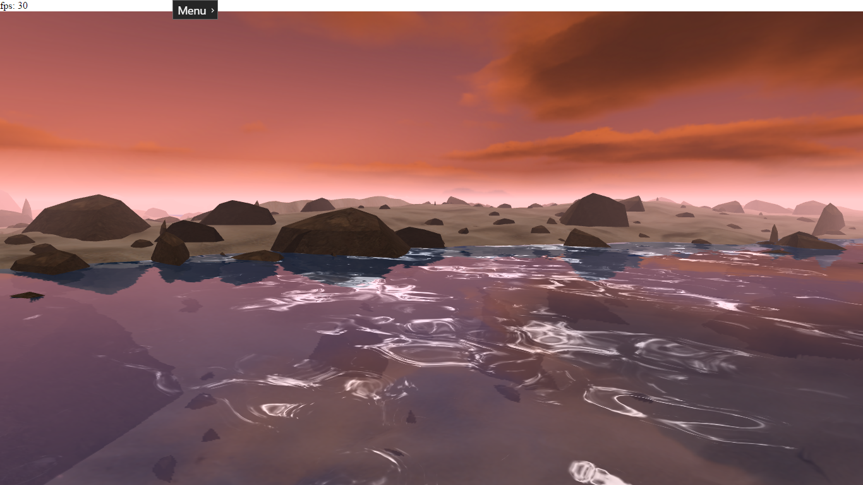

**Sprint 8**

This sprint contained heavy testing and documentation as the water and skybox had been finished. Also added loads of unit tests throughout the project, as most of the tests from the test table where no longer valid. Some tests from the original document remain.

Additions:

* Terrain + rock generator unit tests (time: 15h) (priority: 7)
* Day/night cycle + changed skybox (time: 15h) (priority: 6)
* User interaction (time: 10h) (priority: 5)
* Better collision with terrain (time: 01h) (priority: 2)
* Added max height user can go (time: 01h) (priority: 2)

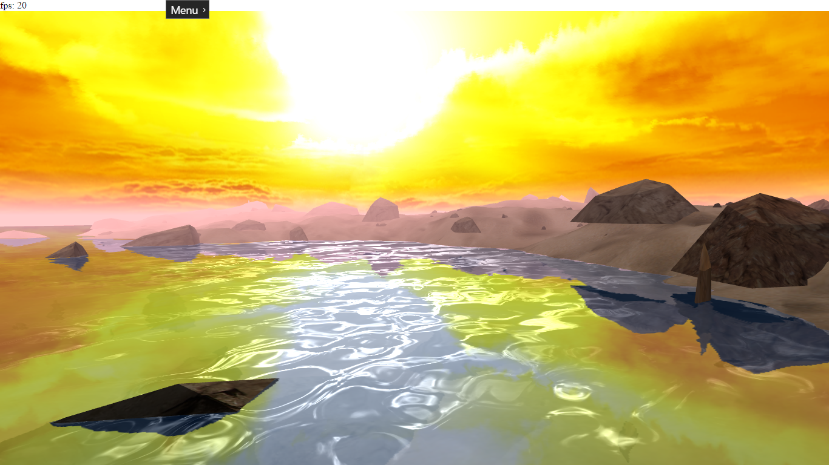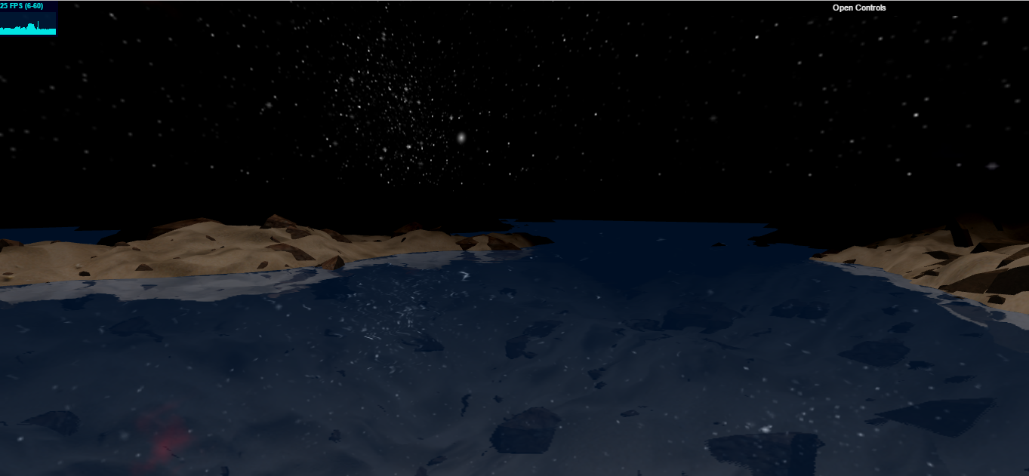

**Sprint 9 + Sprint FINAL**

Started write up

Additions:

* Minimap

